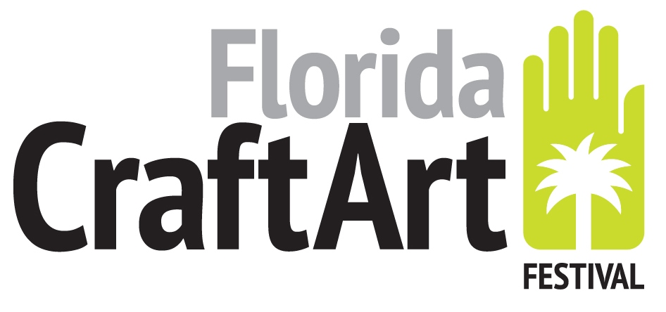
501 Central Ave., St. Petersburg, FL 33701
(727) 821-7391 www.FloridaCraftArt.org
Contact: Katie Deits, Executive Director
or Katie @floridacraftart.org
Florida CraftArt’s 2019 CraftArt Festival
12 of the nation’s best contemporary fine craft artists presented with $10,000 in awards

FOR IMMEDIATE RELEASE, November 25, 2019, St. Petersburg, Fla.; More than 15,000 people attended Florida CraftArt’s 22nd Annual CraftArt Festival presented by the Red Apple Group, along with a myriad of sponsors.
"As a sixth generation St. Petersburg native, I couldn't be prouder of our statewide presence and success through Florida CraftArt Festival this weekend,” said Tyler Jones, Board President of Florida CraftArt. “From artist demonstrations to children's hands-on activities, our community has again shown the power of fine craft in bringing people together. It is this culture that defines St. Petersburg as THE arts destination in which to live and visit. Thanks to all our patrons for the continued support!"

Of the 108 artists from 23 states, 12 were awarded a total of $10,000. Fiber artist Leeann Kroetsch won the show’s top prize of $3,000 for Best of Show. The award was made by Raymond James Financial Services. Artist awardees were selected by this year’s juror Sarah Schultz, the Executive Director of the American Craft Council. Additional awards were presented as follows: Awards of Excellence went to Wesley Rasko (Glass), Kevin Knittel (Mixed Media), William Kidd (Ceramics), Jessica Weiss (Jewelry). Awards of Merit were given to Obayana Ajanaku (Jewelry), Audry Deal-McEver (Ceramics), Julie Krueger (Glass), Larry Maynard (Wood), Alice Pickett-Lewis (Mixed Media), Nick Reale (Wood).
Long dedicated to engaging and mentoring the next generation of fine craft artists, Florida CraftArt again featured the talents of six emerging artists (representing ceramic, wood and mixed media) with the support of the DMG School Project. Showing and selling their work at the festival alongside the nation’s best fine craft artists, each “Emerging Artist” receives a free booth, professional photography session, postcards, and the opportunity to show and sell their work at the annual festival. And among those presented with awards this year, was Emerging Artist Claire McCauley. In addition to the DMG School Project, additional Emerging Artists sponsors are Kevin Beck, Kathryn Howd, Barbara Sansone, and Robert F. and Alexandria Welker.

Additional festival sponsors include Regions Bank, Raymond James, The Don CeSar, Tricera Capital, Acropolis Greek Taverna, St. Pete/Clearwater International Airport, Brian James Photography, The City of St. Petersburg, the Division of Cultural Affairs for the State of Florida, Tampa Bay Times, Creative Loafing, and WUSF.
CraftArt Festival 2019 is a destination in which tourists and locals enjoy a fun-filled, visually exciting Florida weekend. Collectors and art lovers are delighted by the creations of the nation’s best contemporary fine craft artists handmade works in ceramics, fiber, glass, jewelry, metal, paper and mixed media. With something for everyone, the festival also features artist demonstrations, food trucks, craft beers, a children’s art activity tent and live jazz. The annual two-day festival kicks off the holiday shopping season each year the weekend before Thanksgiving.
Florida CraftArt is Florida’s only statewide nonprofit organization representing established and emerging fine craft artists. For nearly seventy years, Florida CraftArt has advanced and celebrated Florida’s fine crafts, in St. Petersburg and throughout the state as Florida’s primary authority for fine craft art. Its engaging and thoughtful cultural programming enlightens, inspires and brings the joy of art to all. Florida CraftArt’s mission is to grow the statewide creative economy by engaging the community and advancing Florida’s fine craft artists and their work. Visit Florida CraftArt at 501 Central Avenue in St. Petersburg.
CUTLINES FOR PHOTOGRAPHS:
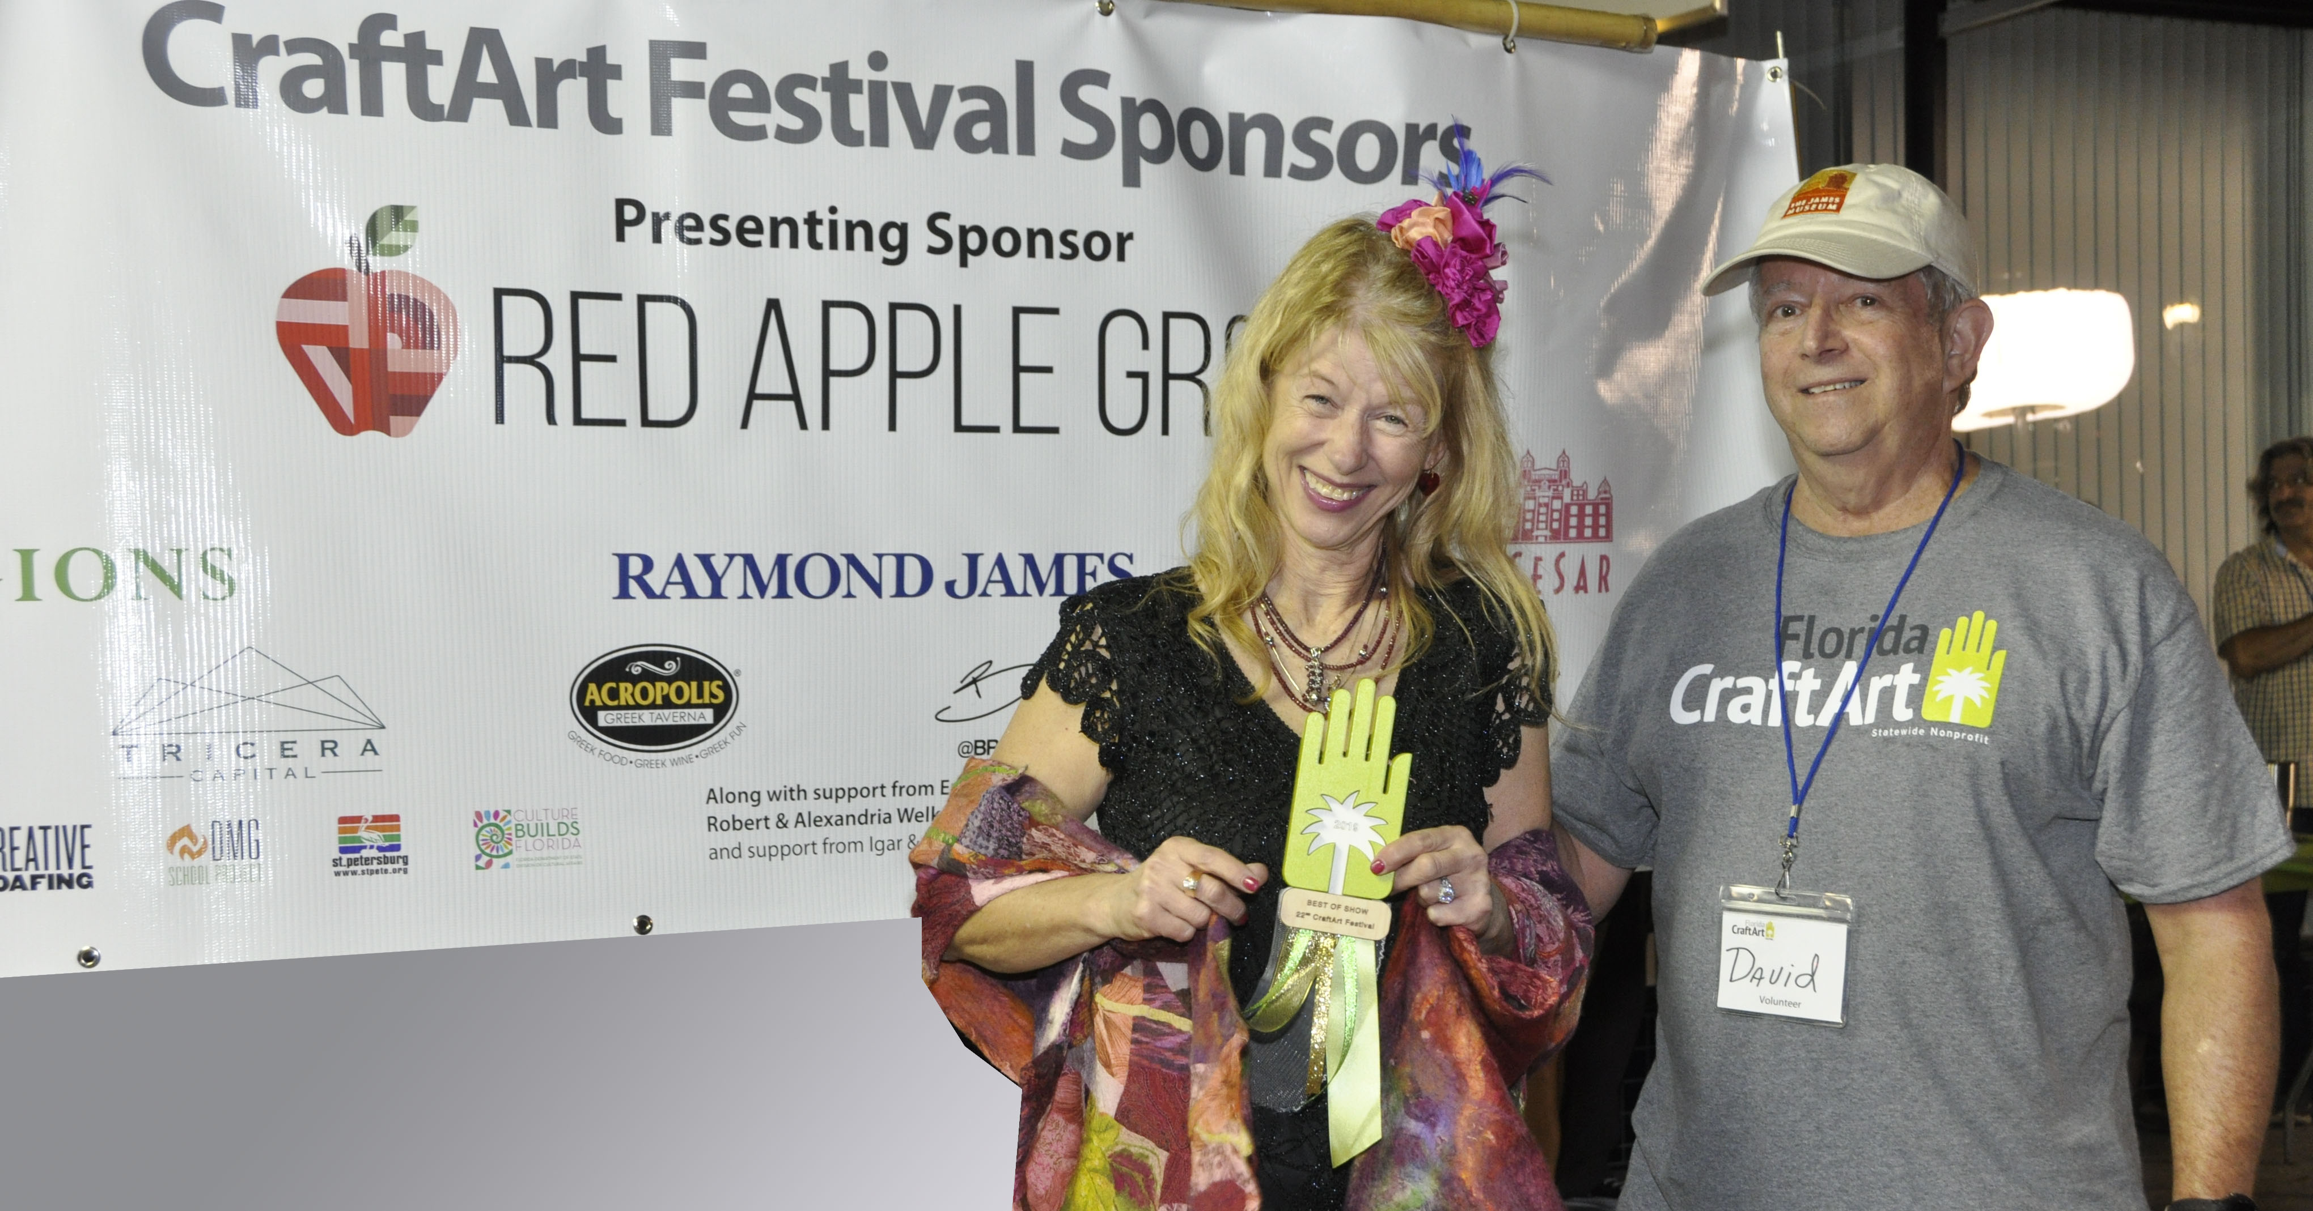
Best of Show Leaann Kroescth.jpg
Best of Show awarded to contemporary fine craft fiber artist Leann Kroetsch. A $3,000 check was presented by David Ramsay, Raymond James Financial Group. (Photo by Katie Deits)

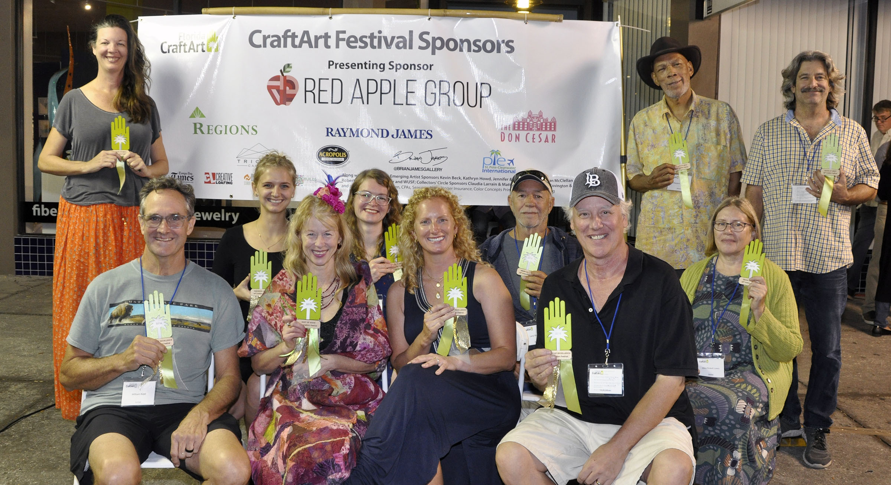
Group shot of Award Winners.jpg
CraftArt Festival Award winners are (front from left): William Kidd, Leann Kroetsch, Jessica Weiss, Kevin Knittel, (back from left): Julie Krueger, Claire McCauley, Audry Deal-McEver, Larry Maynard, Obayana Ajanaku, Alice Pickett-Lewis and Nick Reale. (Not pictured: Wesley Rasko. (Photo by Katie Deits)
.

